**ĐỀ ABC COMPANY**

**1.**

**Functional Requirement:-**

**Payroll Admins's role**

* The system only allows administrators to add, delete and change information of employees.
* Administrative's report must be prepared, accessed and modified only by the admins.
* Adding designation of employees, department and related description

**Employee's role**

* The system shall respond to the queries entered by the employees.
* Employees should be able to log all changes to their existing data.
* Employees should be able to get information regarding their total working hours, pay, commission etc.

**Non-Funcional Requirement:-**

* It should be able to handle large amount of data efficiently and comfortably.
* It must be designed in a way 24/7 hours and easily available to the users.

**2.**

The Payroll Admin should get a approval mail so that , the payment will be processed to the employees post approval.  
The Payroll admin can view the employess working hours.  
As an employee , we must have a calender to choose date and hour.  
Must have option to select not working/ sick leave option.

**3.**

The give description of the software states that the software is required to:  
a) be completely accurate as its the application of employee payroll  
b) the requirements are fixed  
c) project size id medium  
d) need to use the legacy system for database  
Thus V-Model is the best Software development model for the given scenario.

Consideration for selecting the model:

1. Requirement Characteristics:  
a) The software is required to be reliable and there is no chance that customer can tolerate the  
issue in the functionality. Thus the software is needed to be bug free.  
b) The requirement are fixed and the size of the project is medium.  
c) There is no chance of change in requirement as the requirements are well defined by the  
customer  
d) The requirements are well defined at early stage of the project. The no f requirement, expected  
output and features are well sure by the customer.  
2. Development Team:  
a) The team size is medium and there is nothing mentioned about the change in the team size.  
b) The development team will well understand the requirements and they will also get the support  
from the customer side to understand the existing system and the database.  
3. User involvement:  
The user is less involved in the project, they will provide the requirements and does not want any  
involvement or feedback in-between the development.  
4.Existing system to be re-used: Legacy system is already available which is to be accessible by  
new system i.e. a blueprint of the database is available to be used as it is without access to modify  
it.  
5. Delivery: There is no need of smaller versions of the software to be delivered to the customer.  
The final software is to be delivered to the customer at the end of the development.  
6. Need Verification: As the payroll system application needs to be major error free, the verification  
is needed to be performed at each stage of the development which will be assured in V Model

Thus from the above considerations, it can be conclude that the V model is best model to be  
adopted for the development of the given system.

**4.**

Regarding Maintain employee Information :

i) Employee having certain Eid , should fill up the timesheet in every 15 days/ Month.

ii) A Mail should trigger to the manager of that employee to approve or reject of any mis-fillup.

iii) Once the approver approve according to the pay scale employee will be get paid.

**ĐỀ WYLIE COLLEGE**

**1.**

Functional requirements in the system

(i). A registration and login page

(ii). Email Confirmation after login.

(iii). A data storage System where all the data of students would be stored.

(iv). Support email for the new students if they seek help.

(v). Search should be allowed for students to search the courses required.

(vi). There would be a different database to store the courses video or they should be uploaded to any cloud too.

(vii). which courses are available and which are not should be appear infront of the course.

(viii). A proper description of the classes in which that student is enrolled.

(ix). Recommendation of courses according to the searches of student.

(x). There would be a auto password feature on the login page which gives impressive touch to the application.

(xi). And at last if any student want to refund his money there should be a support team to review each application.

Non - Functional requirement.

(i). The webserver could accept more request then normal.

(ii). The DBMS will be easy so that data analyst could easily retrieve the data.

(iii). UI would be more impressive and soft.

**2.**

User story 1:

* As a student , I want to register for courses so that I can get all the related information and view report cards from the personal computers attached to the college campus.
* Given that at the beginning of each semester,when the student requests for course catalog,then the list of courses,related professors,departments,prerequisites to be displayed.
* Given that at the time of selection, when the student selects a course the number of students in the course should be more than 3 and less than 10.
* Given that the course selected by fewer than 3 students, then the course is cancelled.
* Given that the time of selection,when the students wants to change the course, then it can be edited.
* Given that the application process is completed,then bill for the selected course in tha semeter is displayed.
* Given that at the end of semester, when the student log in with credentials, then the report card is displayed.

User story 2:

* As a professor, I want to access the online system so that the grades of students can be added and view their records.
* Acceptance Criteria: Given that the professor wants to sign up the system then he can indicate the course taught by him.
* Given that the professor signed up, then he can view the students who selected his course.
* Given that the professor wants to update the grades in his course, then he can view the record of students in each class.

**3.**

The types in the lower quadrants of the chart being sequential (developement processes - dev, QA , deployment) done in steps rather than iteratively are easy to implement, use and manage. These models imply low customer involvemen eg - Waterfall, V-Model

As you move higher and towards right side of quadrant, the process becomes less rigid and offers more flexibility when it comes to changes in the requirements for future software. These models are more cooperative and include customers intot different stages of software development cycle. eg-Scrum, Kanban, XP -collectively called Agile methodology.

As mentioned in problem statement - due to federal funding the college cannot replace the entire system at once and thus it is advisable to go about developement in phases or cyles. Feedback from the stakeholders - students and teachers is important and requirements understanding is also clear and unserstood per problem statement.

A suitable developemnt model would be Agile(scrum). In general, at the heart of Agile are iterative development, intensive communication, and early customer feedback. In Agile we may choose Scrum as development lifecycle method - Scrumis probably the most popular Agile model.The iterations are usually 2-4 weeks long and they are preceded with thorough planning and previous sprint assessment. No changes are allowed after the sprint activities have been defined leading and have extensive stakeholder feedback and involvement

The team size of 4 developers, 2 QA and a team lead who usually functions as Scrum master is also fits the criteria for Scrum software development model, as the team can pick developement work in phases as required. The requirements for each sprint can be defined based on budget and priority of the functionality, QA in each sprint ensures reliability. There may be a smaller user involvement in project for sprint planning or feedback and suits this developement model.

**4.**

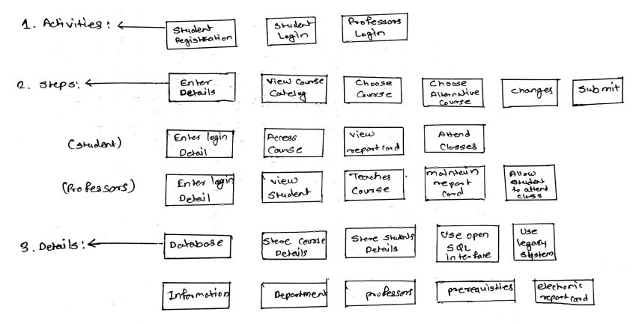

**THAM KHẢO**

- Functional: what the system should do

* Business Rules
* Transaction corrections, adjustments and cancellations
* Administrative functions
* Authentication
* Authorization levels
* Audit Tracking
* External Interfaces
* Certification Requirements
* Reporting Requirements
* Historical Data
* Legal or Regulatory Requirements

- Non-Functional: how the system work

* Performance:
* Response time
* Throughput
* Utilization (what??? Cái quái gì thế này)
* Static Volumetric (:( lần đầu nghe)
* Scalability: Khả năng mở rộng của phần mềm. Theo bần tăng nghĩ thì cái này có nghĩa là: khi mà tự nhiên thêm 1 chức năng mới, hay 1 yêu cầu mới vào thì có dễ dàng dev không?
* Capacity:
* Availability
* Reliability
* Recoverability
* Maintainability
* Serviceability
* Security
* Regulatory
* Manageability
* Environmental
* Data Integrity
* Usability
* Interoperability (?? cái gì đây)

- Example of Functional Requirement:

* The software automatically validates customers against the ABC Contact Management System
* The Sales system should allow users to record customers sales
* The background color for all windows in the application will be blue and have a hexadecimal RGB color value of 0x0000FF.
* Only Managerial level employees have the right to view revenue data.
* The software system should be integrated with banking API
* The software system should pass [Section 508](https://www.section508.gov/) accessibility requirement.

- Example of Non-functional requirement:

* Users must change the initially assigned login password immediately after the first successful login. Moreover, the initial should never be reused.
* Employees never allowed to update their salary information. Such attempt should be reported to the security administrator.
* Every unsuccessful attempt by a user to access an item of data shall be recorded on an audit trail.
* A website should be capable enough to handle 20 million users with affecting its performance
* The software should be portable. So moving from one OS to other OS does not create any problem.
* Privacy of information, the export of restricted technologies, intellectual property rights, etc. should be audited.

